Machu Picchu – Technological Wonder of the World

Giancarlo Perez-Flores
New Jersey City University
EDTC803: Data Analysis and Report Writing
Dr. Tracy Amerman
July 29, 2020

Machu Picchu – Technological Wonder of The World
“Machu Picchu is tangible evidence of the urban Inca Empire at the peak of its power and achievement” (National Geographic, 2010). This old Inca citadel is one of the seven new wonders of the world and has been labeled as a World Heritage Centre by UNESCO since 1983 (UNESCO, 2020). The ruins of Machu Picchu are a very popular destination for tourists with over half a million visitors per year (Leadbeater, 2017). As a native Peruvian, Machu Picchu is a source of pride for the architectural and technological achievements of my ancestors. Although, it currently lacks the latest technological innovations that other historical institutions are using to increase engagement for a wider audience like the use of mobile applications, augmented reality (AR), and virtual reality (VR). As an educator, and habitual tourist, I feel that the agencies in charge of the marketing and tourism for this historic landmark can do more to improve the accessibility of the vast resources and discoveries to students and tourists across the globe.
Recent studies by Stage 2 Research (Stage2Studios, 2018) show that almost two thirds of respondents want to see more interactive technological features in museum exhibits. Based on this research, Machu Picchu’s nearly 250,000 visitors per day could increase by adding new AR and VR exhibits (Leadbeater, 2017; Stage2Studios, 2018). New guidelines set in place by the Peruvian government require tourists to hire a guide to access the citadel, but that could be confusing for international travelers due to the many third-party companies that provide guided tours and the language barrier (Ministerio de Cultura, 2020). Thus, the implementation of a mobile app could potentially improve the visit for many tourists by self-guided tours, provide live data to visitors, collect data on visitors preferences, and introduce innovative technology like AR and VR that would increase engagement.
There are currently a few third-party mobile apps that provide self-guided tours, but none are created by the government, nor provide virtual exhibit enhancement features (Hierba Buena, 2014). All of those apps provide a level of self-guided tours with information about the Inca citadel, but only some have reservation features or audio-video explanations. This leaves room to create an app that provides global solutions and information in one platform. The new mobile app should address the issues with securing access to Machu Picchu, the need of private tour guide, and lack of technological enhancements to engage visitors. A concept for the Machu Picchu mobile app should include a ticket reservation feature, audio and video self-guided tours, enhanced maps with key exhibits, highlight AR enhanced exhibitions, educational features, accessibility settings, and perhaps use new technology to provide alerts for social distancing when close proximity to other people using the same application.
Many museums, like the Louvre in France, have begun to introduce enhanced technological features in their mobile apps as shown in Figure 1. Many exhibits include audio and video recordings that supplement background history details easily missed. Visitors can easily navigate the museum through interactive maps that provide directions around the gallery. Research shows that adding features like x-rays of paintings and time-lapse videos of restorations through mobile apps enhance the experience of the visitor, deepening their understanding and interest for the installation (Stage2Studios, 2018). The new Machu Picchu app can implement all these features allowing the visitor to enhance their experience through videos of initial excavations, audio bits from historians, fables and tales about the Inca empire, and using the interactive map to locate artifacts and special exhibits. Using the GPS technology from the mobile device the app would highlight nearby structures and displays, and show wait times or schedules for presentations and exhibits. Embedded with contact tracing technology developed by Apple and Google the application can notify users when they are not social distancing enough or alert for exposure to COVID-19 (Apple, 2020). The app can be further improved by adding the content in multiple languages making it accessible for visitors from different parts of the world.
Figure 1.
The Louvre Museum Mobile App.
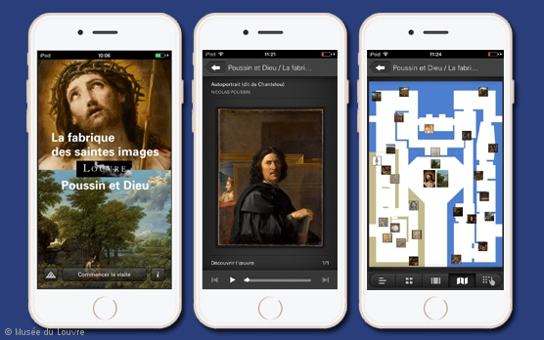
Note. Images of the Louvre mobile app highlighting (from left to right) exhibits, audio/video enhanced features, and interactive map (Louvre, 2020). https://www.louvre.fr/en/exhibition-app. Copyright by the Musee de Louvre.
Adding digital and interactive features to otherwise inanimate objects increases interest in the current millennial generation that is so driven by digital content (Young, 2016). Lexico (2020) defines augmented reality as a computer-generated image that overlays the user’s view of the real world usually through a camera lens. Current advances in technology make augmented reality easily accessible, and many museums are already taking advantage of these features. In the article Technology is Bringing Museums Back to Life, Evans (2017) talks about the success of Chief Technology Officer Mitch Gelman at Newseum using AR to let visitors relive historical events. Likewise, Machu Picchu can use AR to allow visitors to see a digital overlay of the citadel’s evolution through the camera on their mobile devices using the new mobile application, similar to the example on Figure 2. AR can further enhance education by gamifying the visit to Machu Picchu, giving badges and points to visitors for completing tasks like locating artifacts through the AR lens (Parikh, 2019).
Figure 2
Architectural Changes in New York City Through AR View.
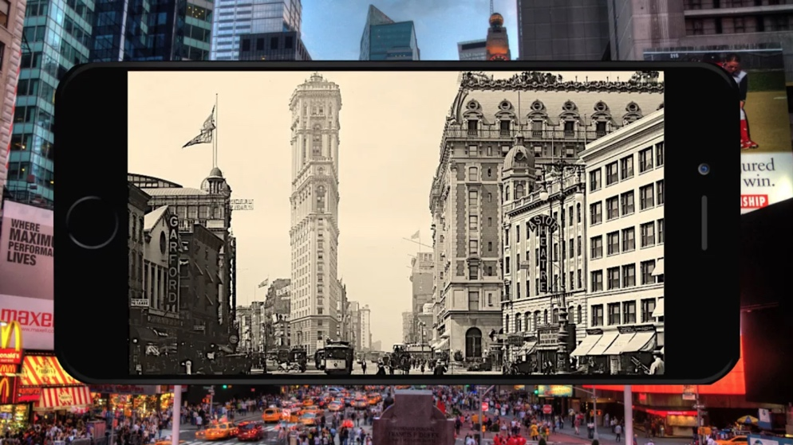
Note. AR app shows how New York City used to look before mayor architectural developments in the phone screen while pointing the camera at the actual live location (Parikh 2019). https://4.bp.blogspot.com/-KBX9qoMVajE/XD6ddYKqm5I/AAAAAAAAFO0/g6PY7ewtPiIuVq-TaH09HoO_m73eQn3LgCLcBGAs/s1600/Screen%2BShot%2B2019-01-16%2Bat%2B2.40.27%2BPM.png
In my experience as a science teacher, virtual reality (VR) can improve interest and learning outcomes by transporting students to places outside the classroom and immersing them in the content. This feature is extremely relevant now that many schools have been forced to teach virtually due to COVID-19 pandemic. The addition of a VR remote virtual tour of Machu Picchu to the mobile app can be extremely helpful to enhance student learning. World history teachers can teach about the Incan Empire, science teachers can show students the technology used by the Incas to construct their citadel or talk about the ecosystem in the Andes. This technology can also be valuable for people that cannot travel due to illness or disabilities, allowing everybody to experience the majesty of Machu Picchu.
The new app can provide a one-stop solution to all the needs of a modern and engaging historical landmark. Although, creating a mobile application with all these features can be expensive. The development of an app with AR capabilities of these magnitude can cost around $300,000 and take almost 1 year to complete (Golosovskaya, 2019). That price tag does not include optimization of online store for tickets, development of interactive map, or implementation of contact tracing firmware. While the Peruvian Cultural Center has created virtual and VR tours of various national museums and historical landmarks, a VR tour of Machu Picchu is not available, creating extra expense (Ministerio de Cultura, 2020). During our current pandemic, using your own device decreases risk of transmission due to using public devices. However, most of the content stored in the cloud relies on a data connection, which could be hard to receive for some international travelers not connected to wi-fi. In contrast, certain users with older device, and limited data storage, might encounter problems storing extra content. This issue could be solved by lending devices, but if not properly sanitized after each use it could increase risk of viral transmission. This issues can be tackled by optimizing the Machu Picchu app to be seamlessly compatible with all devices, which would ultimately increase the price of the app development.
In conclusion, even with the high price tag of developing the Machu Picchu mobile app, the advantages and potential growth are worth it. Data by the Oxford Business Group (2018) shows that tourism accounts for 3.8% of Peru’s Gross Domestic Product (GDP). Implementing these innovative and interactive resources to Peru’s main historical landmark would only increase tourism and public engagement (Evans, 2017). Additionally, all the features on the mobile app are meant to reduce public viral exposure by limiting person-to-person contact, while allowing for maximum interaction with the surroundings. Ultimately, the creation of the Machu Picchu mobile app can prove to be extremely helpful in education, as it could reach people outside of Peru, allowing everybody to experience this wonder of the world virtually.

References

Apple. (2020). Privacy-Preserving Contact Tracing. https://www.apple.com/covid19/contacttracing
Evans, S. (2017, December 13). Technology is Bringing Museums Back to Life. Verdict. https://www.verdict.co.uk/technology-museums-back-to-life/
Golosovskaya, A. (2019, October 5). How Much Does Augmented Reality App Development Cost in 2019? Invisible Toys. https://invisible.toys/create-augmented-reality-apps/augmented-reality-app-development-cost/
Hierba Buena. (2014, December 18). Five Apps to Touring Machu Picchu From Your Phone. https://www.ollantaytambo.org/en/news/five-apps-to-touring-machu-picchu-from-your-phone
Leadbeater, C. (2017, June 21). Will new limits on visiting Machu Picchu save Peru's most famous Inca citadel? The Telegraph. https://www.telegraph.co.uk/travel/destinations/south-america/peru/articles/machu-picchu-new-rules-for-access/
Lexico. (2020). Augmented Reality. In Lexico.com dictionary. Retrieved July 27, 2020, from https://www.lexico.com/definition/augmented_reality
Louvre [Mobile App]. (2020). Exhibition App. https://www.louvre.fr/en/exhibition-app
Ministerio de Cultura. (2020). Visiting Regulations. Retrieved July 27, 2020. https://www.machupicchu.gob.pe/visiting-regulations/?lang=en
Ministerio de Cultura. (2020). Visita Virtualment Nuestros Museos [Visit Our Museums Virtually]. Retrieved July 27, 2020. https://visitavirtual.cultura.pe
National Geographic. (2010, November 15). Machu Picchu. https://www.nationalgeographic.com/travel/world-heritage/machu-picchu/
Parikh, R. (2019, January 19). How can Augmented Reality help bring history to life? Geo AR Games. http://geoargames.blogspot.com/2019/01/how-can-augmented-reality-help-bring.html
Parikh, R. (2019, January 19). Architectural Changes in New York City Through AR View. Geo AR Games. https://4.bp.blogspot.com/-KBX9qoMVajE/XD6ddYKqm5I/AAAAAAAAFO0/g6PY7ewtPiIuVq-TaH09HoO_m73eQn3LgCLcBGAs/s1600/Screen%2BShot%2B2019-01-16%2Bat%2B2.40.27%2BPM.png
Stage2Studios. (2018, June 7). New Survey Measures Demands for VR Exhibits. https://stage2studios.com/2018/06/07/new-survey-finds-museum-visitors-want-more-virtual-reality-exhibits/
UNESCO. (2020). Historic Sanctuary of Machu Picchu. Retrieved July 27, 2020. https://whc.unesco.org/en/list/274/
Young, K. (2016, November 16). What Are Museums Doing to Engage Millennials? The Iris. https://blogs.getty.edu/iris/what-are-museums-doing-to-engage-millennials/

