Expanding STEM Opportunities for Students: An Analysis of Drones in Education

Giancarlo Perez-Flores
New Jersey City University
EDTC 805 CROSS-DISCIPLINE STUDIES IN TECHNOLOGY
Dr. Laura Zieger
November 15, 2020

Expanding STEM Opportunities for Students: An Analysis of Drones in Education
Abstract
The fast-paced evolution of technology has led to the rapid increase of careers in STEM. As the number of STEM-related jobs increase, so does the need to educate our students with the skills and 21st-century competencies required to succeed in them. Currently, drones are used in different industries and represent an expanding job market. This report presents the potential benefits of implementing drone curricula in a school setting.
Introduction
The industry sector has exponentially increased its use of technology to modernize their practice. For example, uncrewed aerial vehicles, drones, have expanded from its initial use in military operations to entertainment, agriculture, and, most recently, to announce Joe Biden as president-elect during a firework show (Tarantola, 2020). The widespread adoption of drones has opened the job market for skilled employees in various positions like pilots, programmers, engineers, designers, and mechanics. Future employees in the drone field need to be technology literate, critical thinkers and have excellent collaboration skills. These skills fall under 21st-century competencies, highlighted as educational priorities by the 2017 National Education Technology Update (U.S. Department of Education, 2017). Schools are beginning to implement 21st-century competencies in all courses, focusing on STEM education to increase exposure to emerging fields in technology. Like Bergen Community College, many higher education institutions are already implementing drones into their curricula to capture aerial imagery and testing ways to infuse other courses with drone technology (EDUCAUSE, 2015). Similarly, the possibilities of introducing drones to secondary education can be beneficial across all subject areas.
Exposure to STEM Opportunities
Although many schools are implementing STEM skills into their curricula through coding, 3D printing, and engineering design, the lack of exposure to relevant real-life applications present a struggle in secondary education. In their analysis of U.S. education, Reimers & Chung (2016) discuss the implementation of 21st-century skills in public schools and stress the need to add comprehensive and meaningful experiences for students to thrive. Schools need to increase student exposure to STEM opportunities while developing 21st-century competencies like computational thinking and peer-to-peer collaboration. The rapid integration of drones in essential career fields creates a demand for schools to adequately equip students with the tools necessary to succeed in the world beyond school. The Association of Unmanned Vehicle Systems International (2017) projects 103,000 new jobs in the drone field by 2025, amounting to an estimated $3.5 billion each year over the next ten years. While the high school offers students the opportunity to learn physics and engineering practices through hands-on robotics classes, increased exposure to STEM careers like drones is necessary to improve students’ success rate in the 21st century.
Using Drones to Increase STEM Exposure
Implementing a Drone Racing Club in the middle school is recommended to increase STEM exposure and provide the foundation for drone use in district-wide curricula. The Drone Racing League (DRL) has developed a STEM program to educate teachers and students in this new exciting technology, DRL Academy. DRL Academy’s program immerses students in science, robotics, and engineering practices while flying drones live and online (Brian, 2020). DRL digital drone curriculum provides students access to the world of drones and drone racing through drone building and flying simulator, virtual lessons with experts in the field of drones & robotics, and instruction from professional drone pilots (DRL, 2020).
The nature of DRL’s program fosters an environment of computational thinking, problem-solving, and team collaboration matching 21st-century competencies. Students develop engineering skills by modifying and testing different drone builds in the simulator. Also, the practices and drone race competitions allow students to collaborate with teammates and rivals. The cost to acquire student licenses vary depending on the class size (Appendix A). Although the school district can budget for implementing a drone program, grants from DRL’s partnership with Eduscape and New Jersey City University (Appendix B) can mitigate part or all of the cost.
Use of Drones Beyond the Club
The drone racing club provides the framework to develop the district-wide implementation of drone classes. Establishing Drone Pilot License pathways provides graduating students that completed the course with the option to finish high school with a technical certificate. The proposal to increase student exposure to STEM fields also includes a professional drone pilot license pathway for high school students. Solidifying student 21st-century competencies and preparing them to succeed in the current job market.
Conclusion
The rapid modernization of different careers, like drones, has exposed the need for innovative educational experiences. Introducing a drone racing club in the middle school provides increased exposure to STEM-related jobs and provides new tools for teachers to engage students in relevant real-life applications. Also, DRL Academy’s curriculum helps students develop critical 21st-century competencies. Through the hands-on activities in relevant applications using drones, students have a better chance to prosper in the real world.
Appendix A
Communication with Drone Racing League Academy
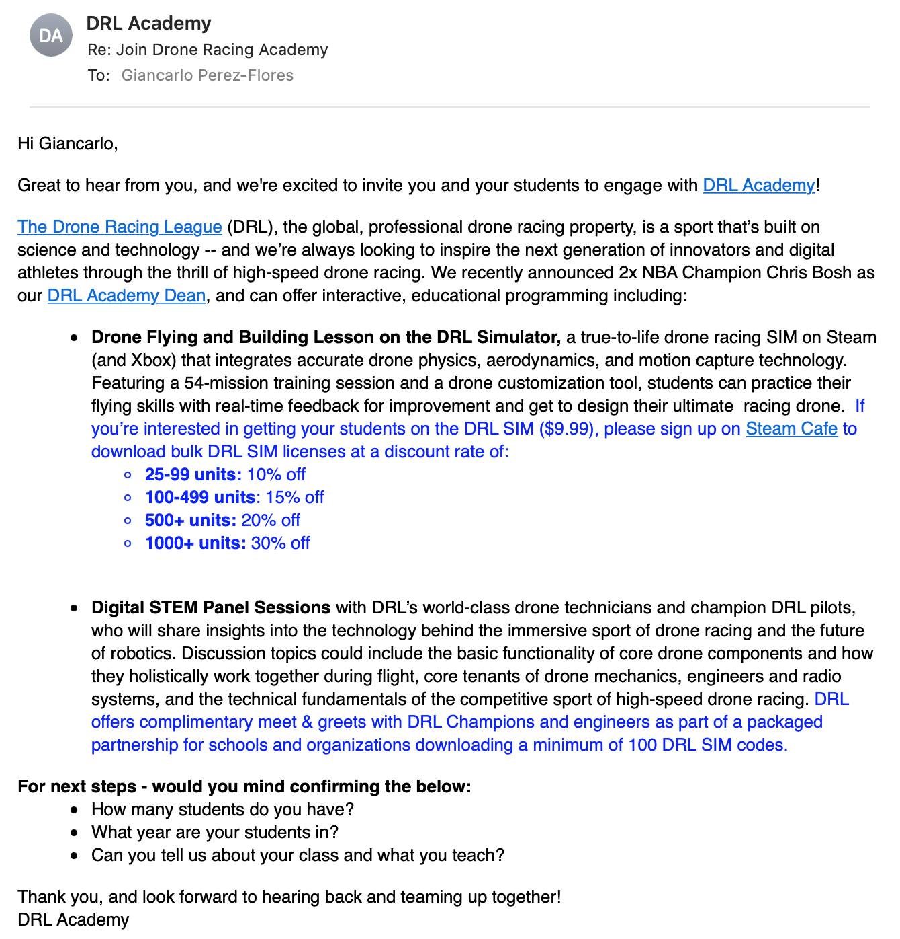

Appendix B
Proposal to Acquire DRL Academy Licenses
At West New York Middle School, we strive to provide a complete education for our students, including preparing them to face the challenges beyond school. The use of drones has grown exponentially, infused into different industry fields like agriculture, surveying and mapping, film, and entertainment displays. Our job as educators is to expose our students to as many tools as possible to help them realize their full potential.
As an Educational Technology doctoral student at New Jersey City University, I have learned about the potential of using drones in education and its versatility to fit curricula across different subject areas. Additionally, the digital curriculum developed for the Drone Racing League (DRL) Academy is advantageous during our global health crisis. The ability to experience drones and hone on computational thinking and engineering skills while working remotely will prove to be extremely necessary.
Introducing DRL Academy into our STEM afterschool program can help us expand our student’s experience with technology and engineering. Further, participating in friendly competition can help our students improve their collaboration skills and 21st-century skills. Financial support to cover the costs of student licenses and drone supplies will provide our district the opportunity to offer an extensive STEM experience for our students and widen their horizons on the possibilities of STEM careers.
I am looking forward to your response and our future partnership in educating and inspiring the future of America.


Appendix C

Proposal for Middle School Drone Racing Club

At our school, we strive to provide a complete education for our students, including preparing them to face the challenges beyond school. The use of drones has grown exponentially, infused into different industry fields like agriculture, surveying and mapping, film, and entertainment displays. Our job as educators is to expose our students to as many tools as possible to help them realize their full potential.
I would like to request permission to create a drone racing club and implement DRL Academy’s curriculum. DRL’s program includes individual licenses for students and provides professional development for teachers and live sessions with students. The DRL program offers an immersive virtual experience with drone technology. The club would meet one hour a day twice a week for the afterschool program’s duration, a total of 64 hours of instruction. While each student’s license is $9.99, a grant to acquire the licenses at no cost is currently under review.
Introducing DRL Academy into our STEM afterschool program can expand our student’s experience with technology and engineering. Further, participating in friendly competition can help our students improve their collaboration skills and 21st-century skills.
Additionally, the digital curriculum developed for the Drone Racing League (DRL) Academy is advantageous during our global health crisis. The ability to experience drones and hone on computational thinking and engineering skills while working remotely will prove to be extremely necessary.
I look forward to your response and our continued commitment to the best education for our students.
References
Association of Unmanned Vehicle Systems International. (2017). Economic Report. http://www.auvsi.org/our-impact/economic-report.
Brian. (2020, March 19). Drone Racing League Launches DRL Academy to Provide Innovative, Digital Education for Students in Partnership with Eduscape. Eduscape. https://eduscape.com/drone-racing-league-launches-drl-academy-to-provide-innovative-digital-education-for-students-in-partnership-with-eduscape/
DRL. (2020). DRL Academy. The Drone Racing League. Retrieved November 15, 2020, from https://thedroneracingleague.com/academy/
EDUCAUSE. (2015, January). 7 THINGS YOU SHOULD KNOW ABOUT ... Drones. Library | EDUCAUSE. https://library.educause.edu/-/media/files/library/2015/1/eli7116-pdf.pdf
Reimers, F, & Chung, C. (2016) Introduction: A comparative Study of the Purposes of Education in the Twenty-First Century. In F. Reimers & C. Chung (Eds.). Teaching and Learning for the Twenty-First Century: Educational Goals, Policies, and Curricula from Six Nations. Harvard University Press.
Tarantola, A. (2020, November 13). The Drones that Announced Joe Biden as the 46th President-Elect. Engadget. https://www.engadget.com/the-drones-that-announced-joe-biden-as-the-46th-president-elect-150014496.html
U.S. Department of Education. (2017). Reimagining the Role of Technology in Education: 2017 National Education Technology Plan Update. https://tech.ed.gov/netp/

